Guide

Program a restlet to receive a barcode from NSPOS, and an amount. This barcode and amount come from an item that gets scanned on POS.

Then the RESTlet receives that barcode and sends it to the API of VenueNext. The API will answer and give back the balance.
We get that balance on the RESTlet, and do the difference between balance and amount. If it’s above 0, then we should respond YES, if not, respond NO.

Customer A purchases Item X with amount $100 on POS -> send that to restlet -> charge on venueNext that $100 and see what happens
we should either get a decline, approve, or partial approve.

I can relate to William Sonoma, to do the RESTlet
I would need access to sandbox for DNC. Use NSPOSWest1.
The VenueNext Wallet Integration document has documents for API.

20hs.

Implementation
We need to get an authorization token in order to access the API operations. To do this:
- Get the authentication token:

Do with postman:
POST Call url: https://portico.qa.mars.vnops.net/devices/login using parameters on body:
{
"app_key": "{{thirdparty_app_key}}", // thirdparty-possandbox-01gfbg9gs19jjbqc6wsrd0j2g5
"organization_name": "orlando_magic", // possandbox
"device_id": "{{thirdparty_device_id}}" // cf3d8a72-7843-4541-a953-c36e2eccd70c
}
Then you get the token there.

Sandbox URL to test:

API URLs:
https://stadium.qa.mars.vnops.net/operator/discount_charge_nonces/info
https://stadium.qa.mars.vnops.net/operator/discount_charge_nonces/charge
https://stadium.qa.mars.vnops.net/operator/discount_charge_nonces/refund
Wallet URL: https://possandbox-qa.ordernext.com/

API Credentials to access the POS Sandbox QA environment: https://share.1password.com/s#deslbKSrBimioyb8rq2xViciUz5C5nmCYtYXxdqBUhs

Here is a link to access the API credentials for your sandbox. This includes the sandbox URL, and the URL for the Auth call to retrieve the token. Plus the additional values required for the body of the auth call.

- Need to know which is the call to get the balance via de barcode. My guess is that it is the API call called “Nonce Info” but not sure we will need to confirm with them.
If that one is the call, we need:

{
"discount_charge_qr": "9a61o4awu82p1pi0", //creo que este es el QR
"revenue_center": "revenuecenter123"
}

We don't have a specific Get Balance endpoint in the "3rd Party POS V2" integration. This is due to the fact that the user can have a stored credit card on file which can be used to charge any amount over the user's virtual currency balance. The /charge API will return in the response the amount that was successfully charged. If the user only has a virtual currency balance of "500" and a request is sent to charge "1000", the API call will return an success response that includes the amount successfully charged as "charged_amount_in_cents":500.

The /info call is used to check for any discount affiliations the user may have, and should be called first so the discount can be applied before payment, for example:
{
"affiliations": ["Season Ticket Member"]
}
Customer A purchases Item X with amount $100 on POS -> send that to restlet -> charge on venueNext that $100 and see what happens
{
"discount_charge_qr": "7986892386443267", // This is the scanned QR code, these can be sent to the /info call more than once, but can only be sent to the /charge call once. . // try generaring it randomly
"amount_in_cents": 100, // Amount to charge in cents passed by mat
"merchant_account_id": "merchant_id", // This value will indicate the merchant account used to settle any charges using the wallet's stored credit card. This value should be configurable per site.
// Example value: 7CFBDCB9-26B5-4841-8AFD-CE99E7381F41 passed by mat
"revenue_center": "revenuecenter123", // This should be any location data you can pass to indicate where the charge took place. At a minimum, "NetSuite" would suffice, but if you have specific location IDs that will help with reconciliation. // Example value: 6172 passed by mat
"check_num": 1234, - This should be an ID that ties back to the order in your system. This field does have requirements that it must be numeric, and no more than 10 digits. Do you have any order ID in your system that will match that format? If so, that is also helpful for reconciliation. // try generaring it randomly
"payment_types": [
"shift4_token",
"credit_card",
"freedompay_credit"
] // descartar esto
}

The payment_types array specifies allowed payment types. We've had some clients request that Virtual Currency not be used on any Retail order. If that is the requirement at any location, you can pass in the above payment types to only allow the stored credit card payments. If that is not a requirement then this array would not be required at all. // skip it

Testing
Accedo a:
https://possandbox-qa.ordernext.com/wallet con el numero de teléfono de Mat: 7029341423, le pido el código a el.
Una vez tenemos la cuenta creada, le pedimos a la gente de venueNext que nos agreguen una virtual currency, y un discount affiliation para ser capaz de generar códigos QR cuando sea necesario.
Luego accedo a: My Wallet
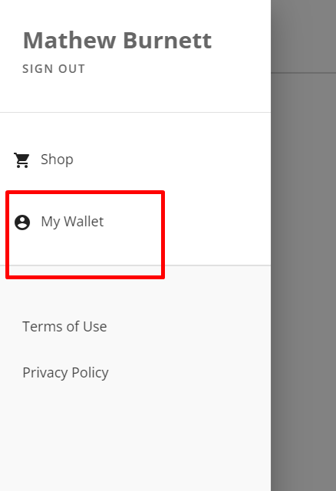
Luego en QR Code Pay, que generará un QR nuevo cada vez que apretemos:
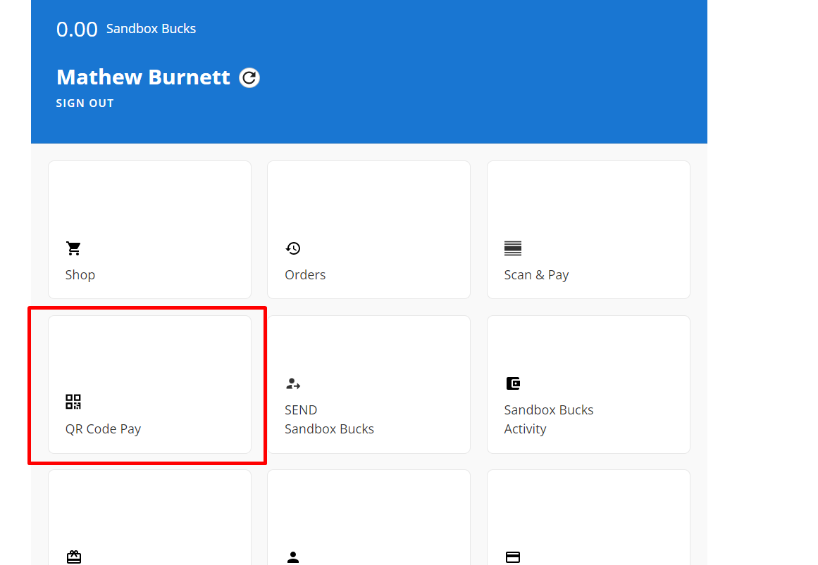
Este QR lo obtenemos mediante la extension instalada QR Code reader:
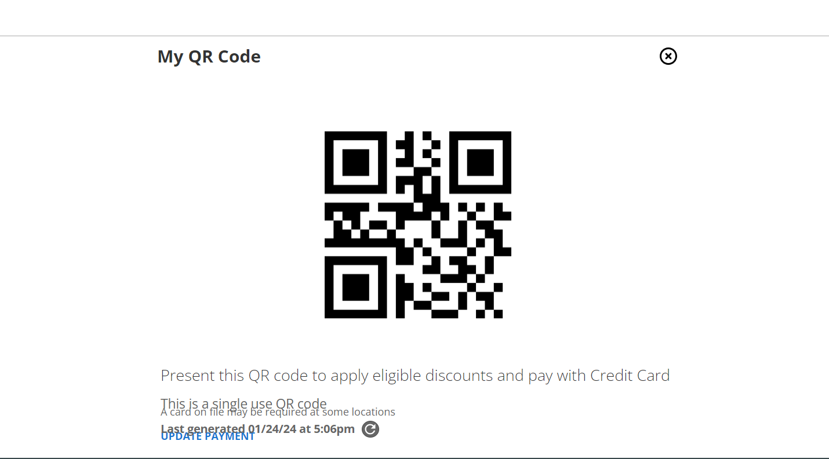
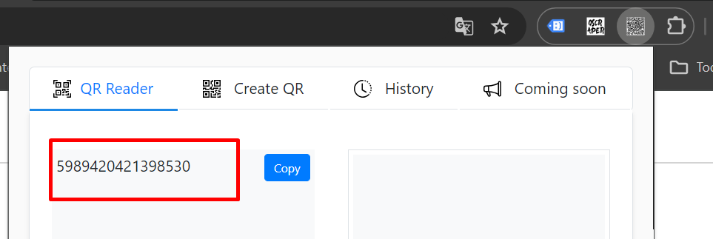
Y este será el valor del scanned QR que usamos en nuestra transacción en POSTMAN, o en el script nuestro.
Podemos usarlo en la operación “charge” una sola vez, luego se vence.
Entonces, corremos y nos da:
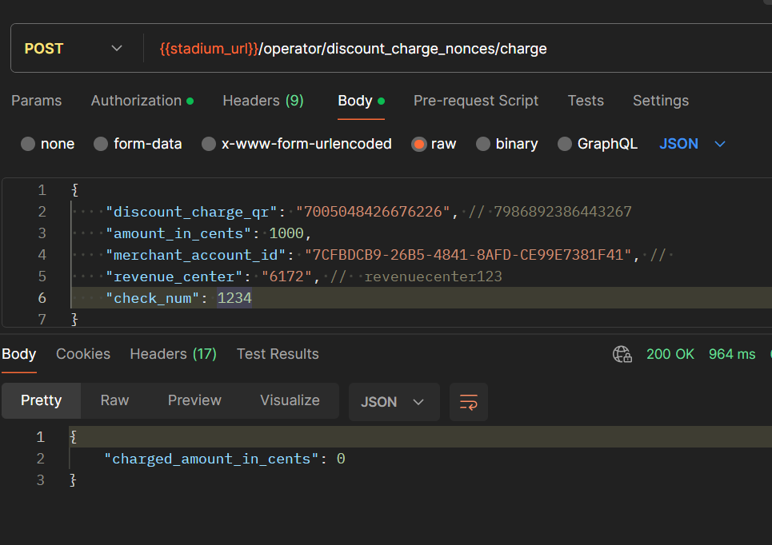
Siempre nos va a devolver 0 porque no nos cargaron un valor. Esta cory nos tiene que cargar algo.

